**Name – Parag Gattani**

Program No. – 06

Program Title – Fire Alarm using flame Sensor

**AIM**

Design an alert system using flame sensor.

**HARDWARES REQUIRED**

* Arduino Board
* Piezo
* Temperature Sensor
* Breadboard small

**CIRCUIT DIAGRAM**

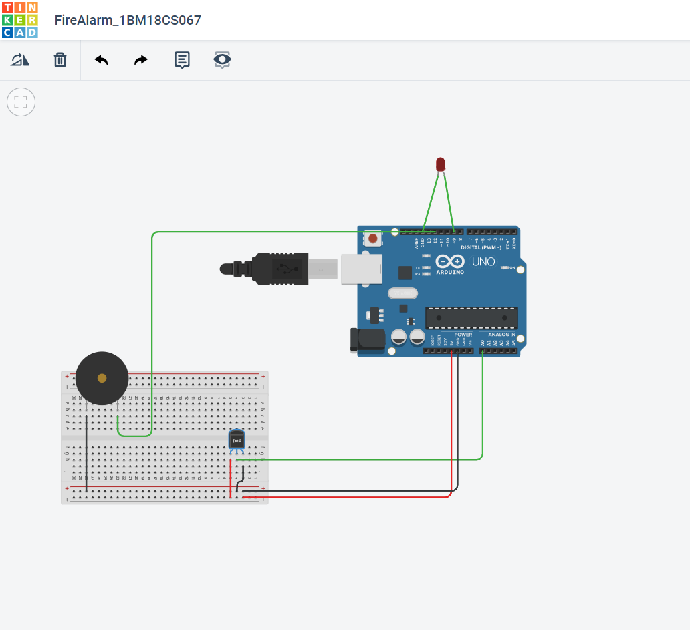

**WRITE-UP**

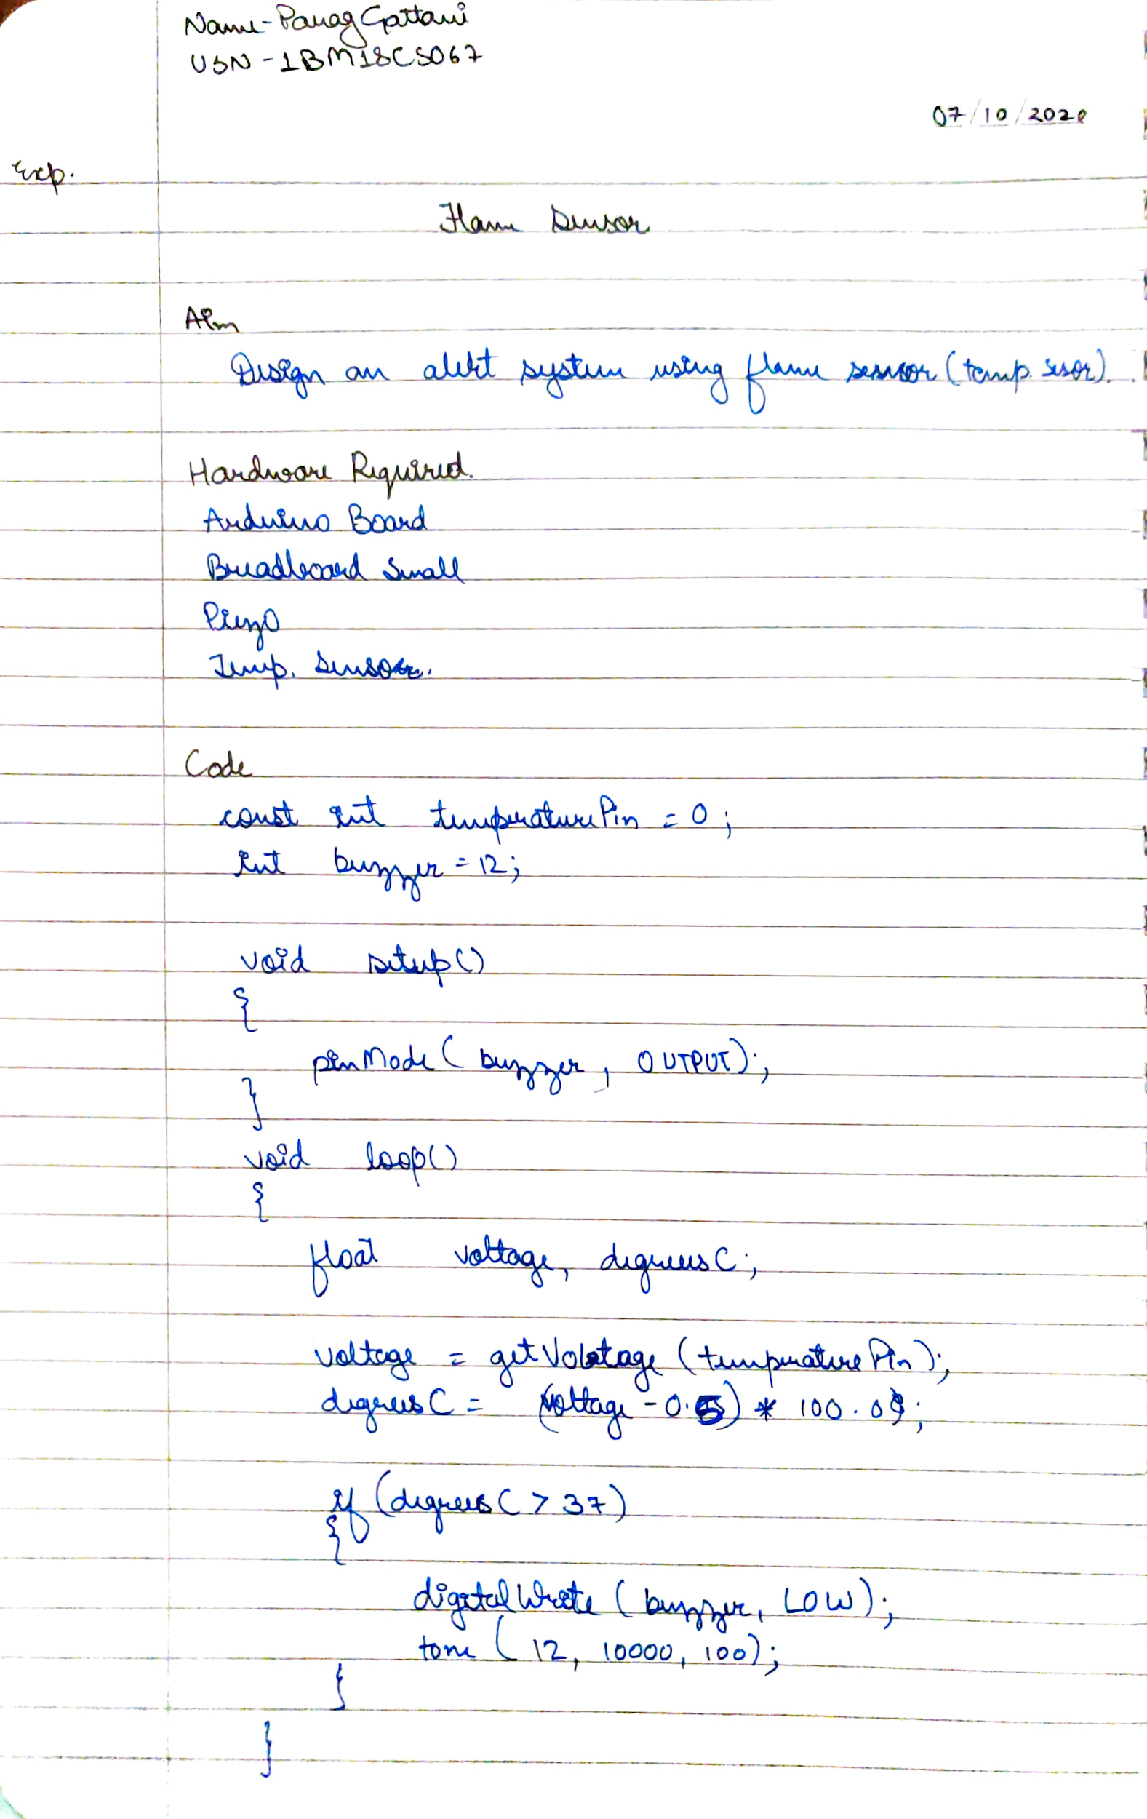

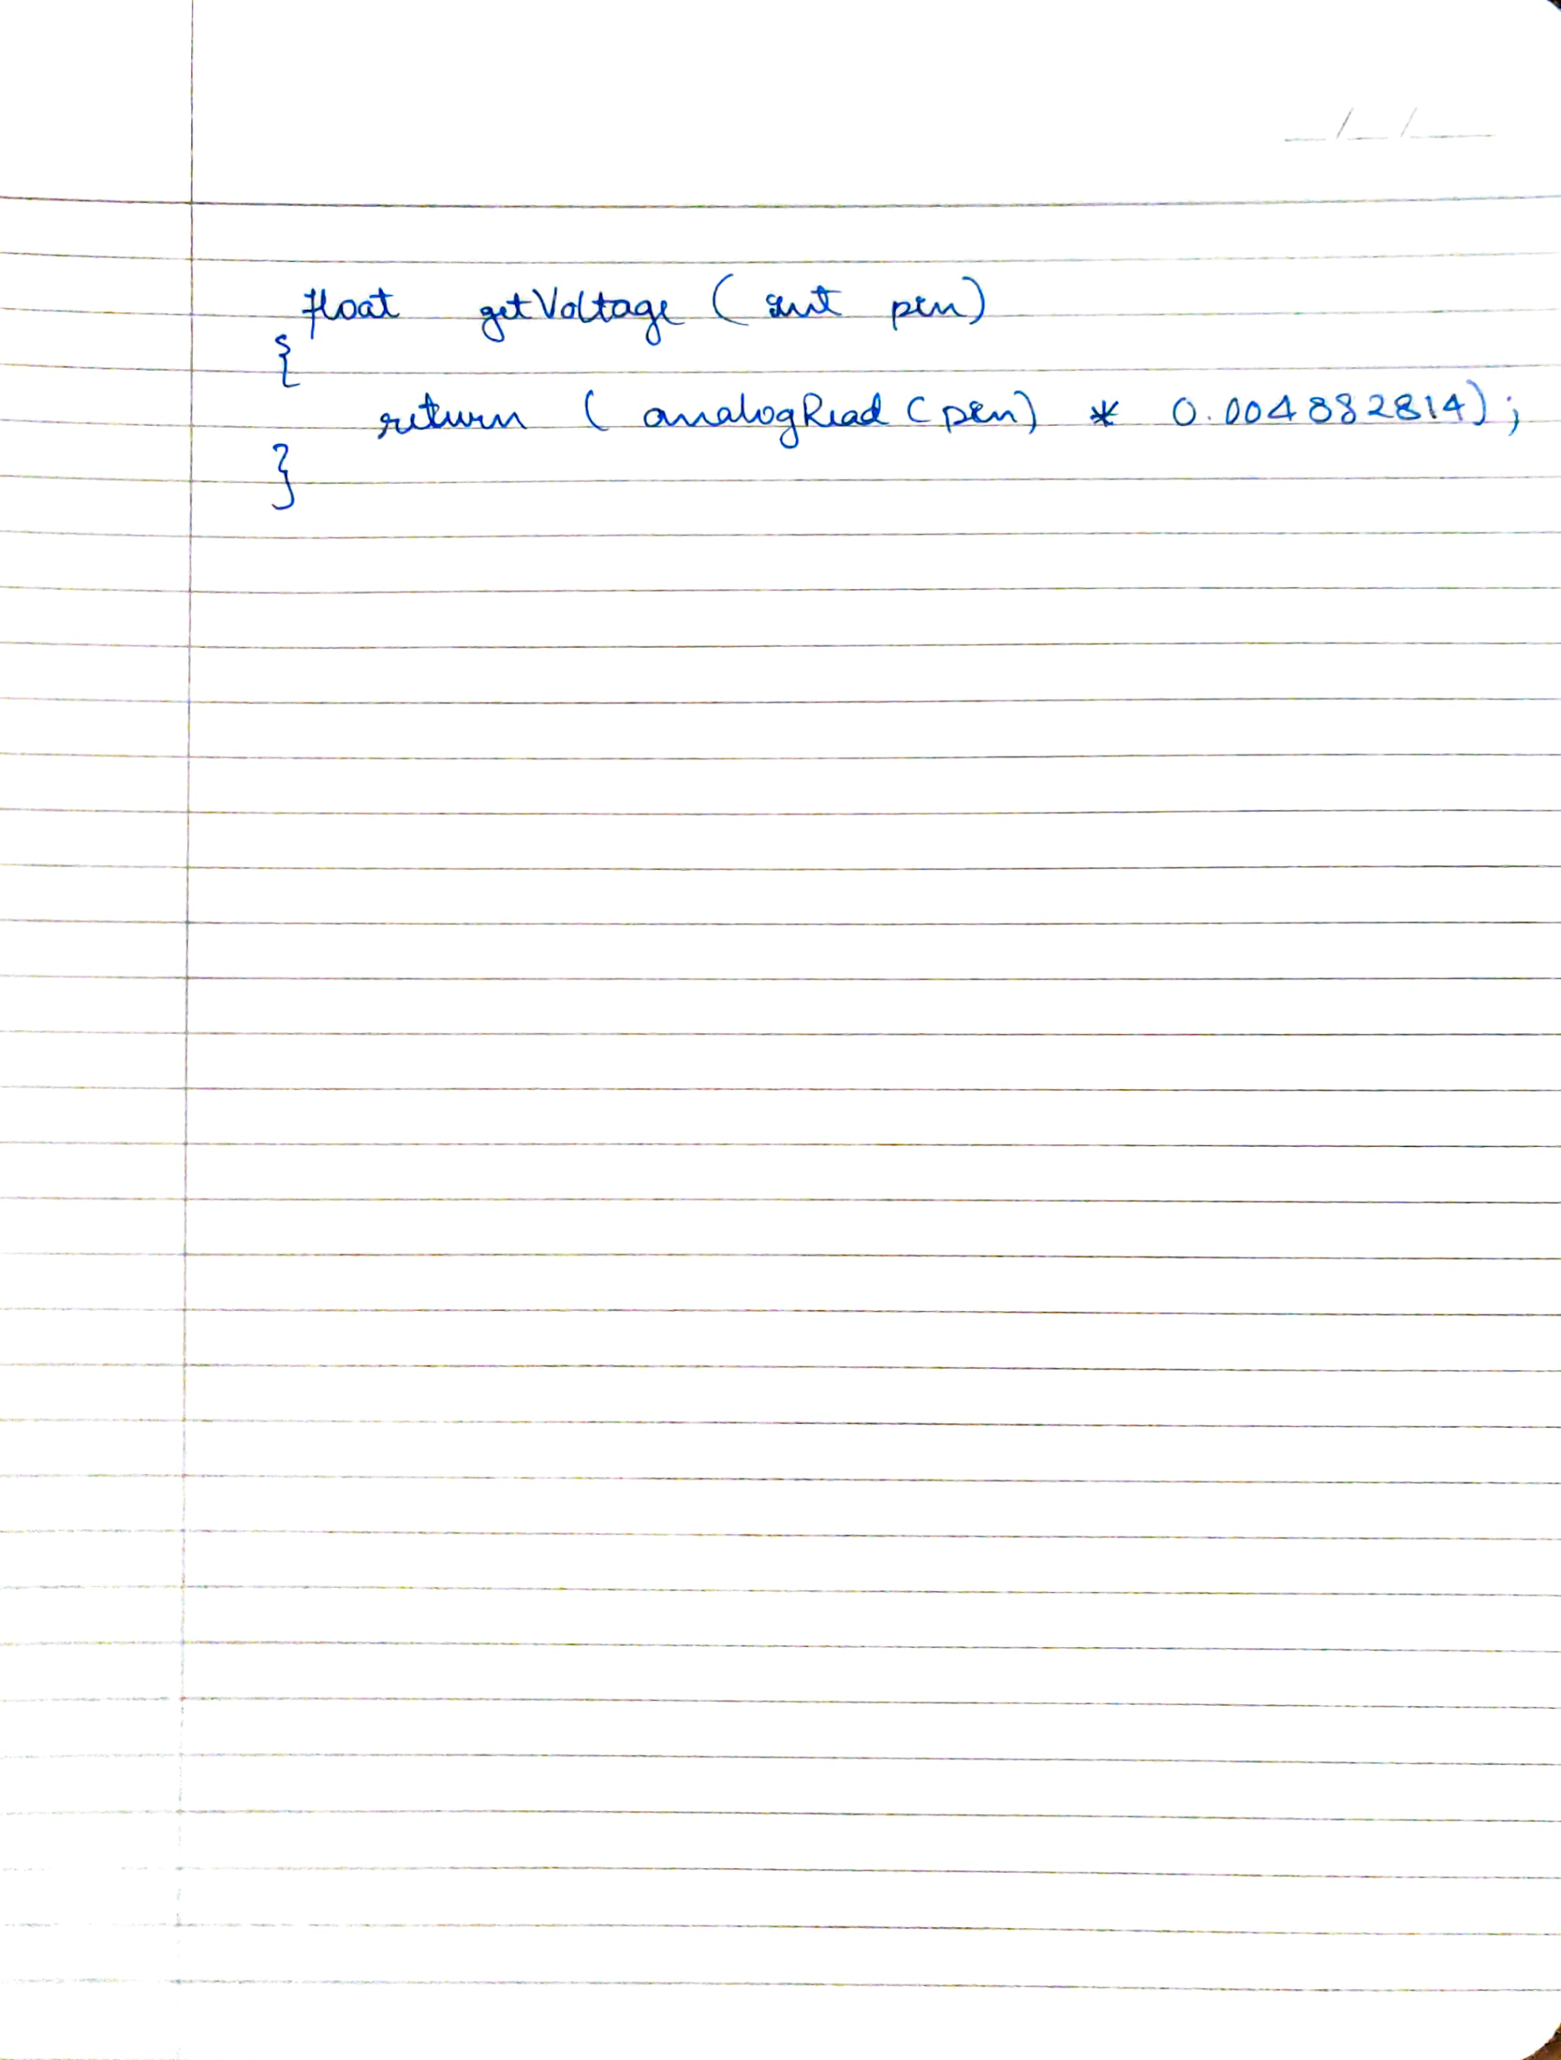

**CODE**

const int temperaturePin = 0;

int buzzer = 12;

void setup()

{

Serial.begin (9600);

pinMode(buzzer, OUTPUT);

pinMode(9, OUTPUT);

}

void loop()

{

float voltage, degreesC;

voltage = getVoltage(temperaturePin);

degreesC = (voltage-0.5)*100.0;

if(degreesC < 37)

{

Serial.print(degreesC);

Serial.println(" SAFE!");

}

if(degreesC > 37)

{

Serial.print(degreesC);

Serial.println("FIRE !!!");

digitalWrite(9, HIGH);

digitalWrite(buzzer, LOW);

tone(12, 10000,100);

delay(100);

}

}

float getVoltage(int pin)

{

return (analogRead(pin) * 0.004882814);

}

**OUTPUT**

Designed an alert system using flame sensor.